**Physical Weathering**

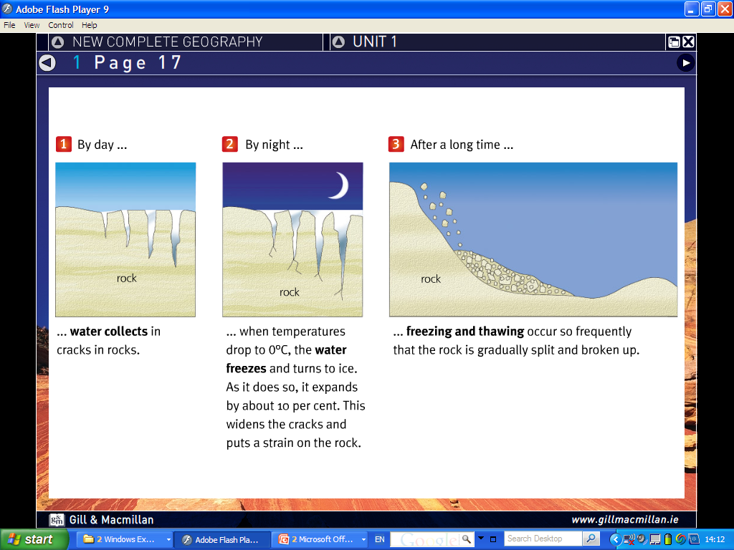In Ireland, frost action, otherwise known as freeze thaw actions occurs in upland areas or all over Ireland in the winter months. This is important because for frost action to happen there has to be precipitation and most importantly the temperature has to continuously rise and fall below 0 degrees (freezing point). In day time water gathers into joins (cracks) in the rock. At night when the temperature drops below freezing the water freezes and expands by 10% putting pressure on the rock. Over repeated nights this causes bits of rock to fall off and roll down the mountain and gather in piles and the bottom. This is known as scree. Freeze thaw action can be seen on Craogh Patrick in Mayo.

**Chemical Weathering.**

The rock that we are looking at is Limestone. An area of pure limestone is known as a Karst region. The most famous example of this is the Burren in Clare. The feature in the diagram is a limestone pavement and is formed mostly by a chemical weathering know as carbonation. As rainwater travels through the atmosphere it takes in carbon dioxide. The rainwater mixes with the water to form a weak carbonic acid. This carbonic acid reacts with the calcium carbonate present in limestone and slowly dissolves the rock. As limestone is permeable (allows water to pass through it) the joints and bedding planes are the first to be weathered; this forms the grikes (which are the spaces between the limestone pavement) and leaves the clints (the slabs of rock).

**Limestone Feature**

1. Limestone belongs to the sedimentary rock group.
2. Limestone can be found in the Burren in Clare.
3. One karst underground landform that I have studied is a pillar. There is an example of a pillar in the Aillwee caves in the Burren. A pillar is usually found in a cave system or a cavern. Water dissolves (carbonation) Limestone as it travels through joints and bedding planes. This water contains a small mineral called calcite. When water drips off the roof of the cave system, the drops leave behind this calcite and builds up over the years to form a stalactite. Likewise when water hits the cave floor it deposits calcite which builds up to form a stalagmite. When stalagmites and stalactites grow and join up the form pillars.

