**The Burren**

**Chemical Weathering and surface features.**

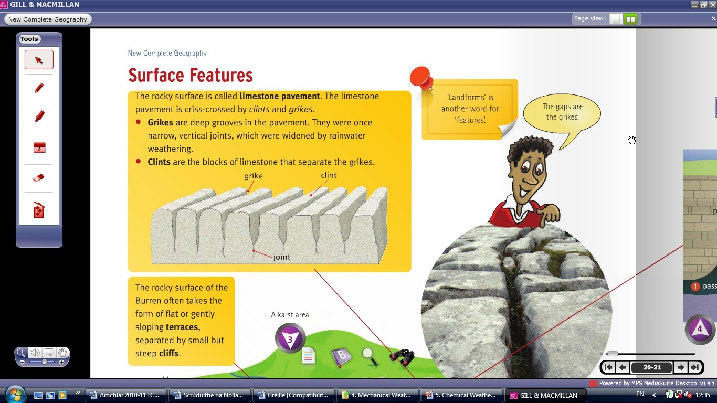

The feature that we are looking at in the diagram is a Limestone pavement. An area of pure limestone is known as a Karst region. The most famous example of this is the Burren in Clare. The feature in the diagram is a limestone pavement and is formed mostly by a chemical weathering know as carbonation. As rainwater travels through the atmosphere it takes in carbon dioxide. The rainwater mixes with the water to form a weak carbonic acid. This carbonic acid reacts with the calcium carbonate present in limestone and slowly dissolves the rock.

As limestone is permeable (allows water to pass through it) the joints and bedding planes are the first to be weathered as this is the weakest point of the rocks. This weathering forms the grikes (which are the spaces between the limestone pavements) and leaves the clints (the slabs of rock).

**Limestone Feature**

1. Limestone belongs to the sedimentary rock group.
2. Limestone can be found in the Burren in Clare.
3. One karst underground landform that I have studied is a pillar. There is an example of a pillar in the Aillwee caves in the Burren. A pillar is usually found in a cave system or a cavern.

Water dissolves Limestone by carbonation as it travels through joints and bedding planes in the rock above the cave system. As rainwater travels through the atmosphere it takes in carbon dioxide. The rainwater mixes with the water to form a weak carbonic acid. This carbonic acid reacts with the calcium carbonate present in limestone and slowly dissolves the rock. This water now contains a small mineral called calcite (dissolved calcium carbonate).

When water seeps and drips off the roof of the cave system, the drops leave behind this calcite on the ceiling. This calcite builds up over thousands of years to form a stalactite which hangs from the ceiling like an icicle. Likewise when water hits the cave floor it deposits calcite which builds up to form a stalagmite. Over thousands of years these stalagmites and stalactites grow slowly until they join up the form pillars.

