2012 Question 1.B. Plate Tectonics Volcanoes
- An example of a volcano I have studies is Mount St Helens in America and Surtsey in Iceland.
- In the diagram two plates are pulling apart to form a volcano. Plates float on the earth’s mantle and are moved by convection currents where hot magma moves up from the core, cools and sinks in a circular pattern. An example of where this happens in the world is the Mid Atlantic ridge. Here the North American and the Eurasian plates are pulling apart. When the plates separate hot magma rises through vents and fissures, to come in contact with contact with cold sea water. Here the lava solidifies to a hard igneous rock and forms new ocean floor. Over repeated eruptions this builds up to form a long ridge of mountains. Iceland is the one of the few places where the Mid Atlantic ridge is above sea level.
2011 Question 1.B.
- The focus is the exact location the earthquake began. It is beneath the Earth’s surface where the crust cracks under pressure and releases energy that shakes the ground.
The epicentre is the point on the earth’s surface directly above the focus of an earthquake. It is here that most damage is done.
A fault is a physical line between two plates where the plates are moving in opposite directions. It is this movement that creates pressure causing an earthquake
- Two countries that experience earthquakes are New Zealand and Japan.
- One method of reducing the impact of earthquake in urban areas is by changing buildings. Do not build high rise buildings, building should have wide bases and narrow tops to be more flexible
2010 question 1.C Fold Mountains
- One feature formed when plates collide is a fold mountain.
- One feature formed when plates separate is a mid ocean ridge.

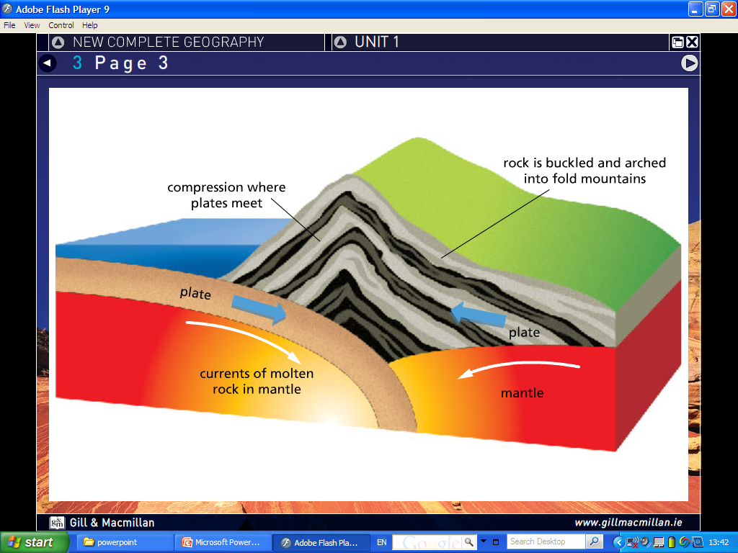
Fold Mountains occur where plates collide. Plates float on the earth’s mantle and are moved by convection currents where hot magma moves up from the core, cools and sinks in a circular pattern. Moving plates collide with each other such as the Andes and South American Plate. When they come together the compression causes the layers of rock that lie on the plates to become buckled and fold upwards forming fold mountains. The Andes and South American Plate made the Andes which are 30 million years old and are Alpine Mountains, so much higher than Irelands Fold Mountains that are 250 million years old that got worn down and are armorican fold mountains.
2009 question 4A Earthquakes
- Earthquakes occur along plate margins such as the San Andreas Fault Line at San Francisco.
- A is the focus, B is the epicentre.
- Earthquakes are a result of plate movement. When plates are sliding past each other at fault line such as the Pacific Plate and the North American Plate they sometimes stick together. This results in a build-up of pressure that when released can release a lot of pressure called shock waves that shake the earth called an earthquake. Haiti recently experienced a large earthquake causing widespread devastation.

2004 Question 3 A Volcanoes
- A is the Magma Chamber, B is the Vent, C is the layers of ash and lava.
- One Igneous rock I have studied is basalt. It is known as a fire rock as it was formed by molten lava. Basalt is black heavy rock with no crystals in it as the lava cooled very quickly on the earths surface. Basalt can be found in the giants causeway in Antrim
- Rocks can be used in many economic activities. Basalt can be used for ornaments, worktops and fireplaces, Limestone can be used in for buildings as well as soil conditioner and the manufacute of iron and steel while marble can be used for fireplaces. Rocks are taken from shaft mines, while oil, peat and gas can also be gotten to make energy and get money.

